A Standardized Machine Learning Model for Land Pricing in Kajiado County
Chapter Four: Results and Discussion
Draft prepared 12 October 2026 · Data: Kajiado North valuation register, 2022–2023

4.1 Introduction
This chapter presents the results of developing and validating machine learning models for land pricing in Kajiado County, following the procedure set out in Section 3.10. It covers how the data were prepared (Stages 1–2), the exploratory analysis (Stage 3), feature engineering (Stage 4), how the data were split for validation (Stage 6), and the development, tuning and evaluation of the six algorithms proposed in Section 3.10.3. It then explains the selected model using the explainable-AI techniques in Section 3.10.6. The chapter ends by discussing the findings against the research objectives and the literature, and by setting out the limitations of the evidence.
All analysis was carried out in Python using pandas, NumPy, scikit-learn, XGBoost and SHAP, as specified in Section 3.10.4. The code is held in three scripts so that the whole analysis can be reproduced: land_price_models.py, compare_models_cv.py and report_figures.py.

4.2 Data Description and Preparation

4.2.1 Data source
The data come from the Kajiado North land valuation register for 2022 and 2023. Each record has a registration section and parcel number, the parcel area in hectares, the assessed value in Kenya shillings (KSh), a short free-text description of where the parcel is ("Situation") and, for part of 2023, the valuation date. The register appears to have been transcribed from handwritten records and needed substantial cleaning before it could be modelled.

4.2.2 Data cleaning
The cleaning covered the issues listed in Stage 2 of Section 3.10.2. Registration sections spelled in different ways (for example NTASHART, NTASHARI and MTASHART) were standardised by fuzzy matching against a list of known sections. Ditto marks in the value and area columns were replaced with the value in the row above. Values written as text (such as "2M") and areas in square metres were converted to consistent units. Entries that were clearly impossible, such as a value of about KSh 4 trillion or an area of zero, were removed. The cleaned register has 2,717 records.
Inclusion criteria for modelling were then applied, in line with Section 3.5.3 (Table 4.1). Because the study focuses on undeveloped land (Section 3.4), records whose description mentions a house, apartment or other structure were excluded. Extreme price-per-acre values below the 1st or above the 99th percentile were treated as likely entry errors and also removed.
Table 4.1: Records retained at each stage of data preparation
Step | Records remaining
Cleaned register (2022 and 2023) | 2,717
Has both an assessed value and a parcel area | 1,507
Vacant land only (no buildings mentioned) | 1,458
Exact duplicate records removed | 1,444
Registration section identified | 1,440
Price per acre within the 1st–99th percentile | 1,410
Source: land_price_models.py, outputs/data_filtering.csv.
The final modelling dataset has 1,410 parcels, which exceeds the minimum of 1,000 records targeted in Section 3.5.4. Because most 2022 records do not have an area, 81% of the modelling records come from 2023.

4.2.3 Exploratory data analysis
The assessed values are strongly right-skewed (Figure 4.1). The median is KSh 1.50 million and the interquartile range runs from KSh 0.40 million to KSh 4.20 million, but the mean is KSh 3.03 million and the largest value is KSh 80 million. The skewness coefficient is 5.6 on the raw scale and −0.8 after a natural-log transformation. All models were therefore trained to predict log(value), and the predictions were converted back to shillings for evaluation. This is standard practice in hedonic and automated valuation work, because it stops a few very expensive parcels from dominating the fitted model.
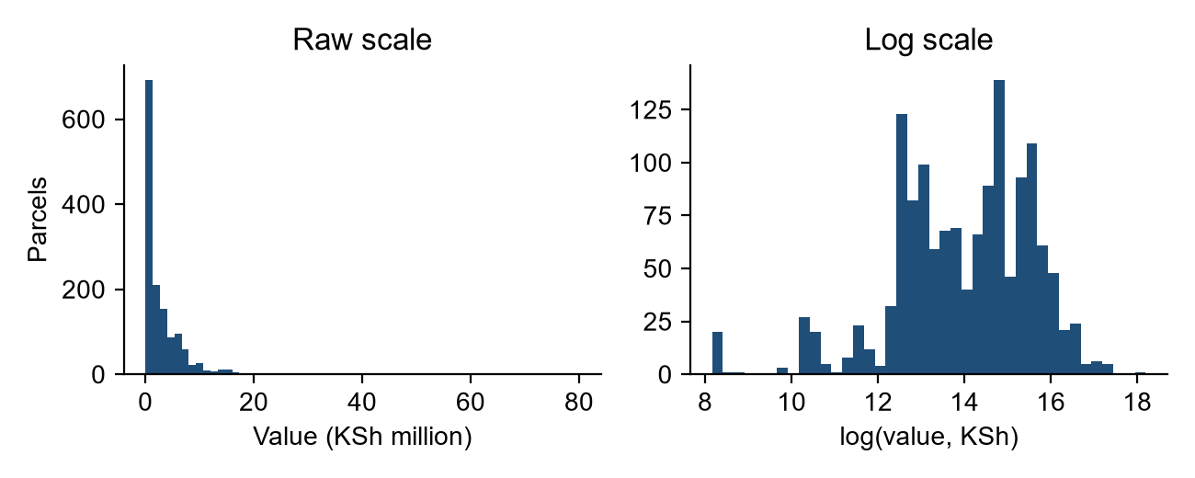
Figure 4.1: Distribution of assessed land values, raw scale (left) and log scale (right).
Location is the clearest source of variation in value (Table 4.2). Ngong and Olekasasi, the more urbanised sections, have median values of KSh 3.5 million. Ntashart, Loodariak and Ewaso Kedong have medians between KSh 0.15 and 0.5 million. Most parcels are small: the median area is 0.05 ha, about one-eighth of an acre.
Table 4.2: Parcels and median values by location
Location | Parcels | Median value (KSh) | Median area (ha)
Ngong | 498 | 3,500,000 | 0.050
Ntashart | 341 | 400,000 | 0.045
Other sections (grouped) | 228 | 1,220,000 | 0.067
Olchoro Onyore | 116 | 800,000 | 0.046
Kipeto | 83 | 750,000 | 0.045
Loodariak | 73 | 500,000 | 0.160
Olekasasi | 27 | 3,500,000 | 0.090
Ewaso Kedong | 26 | 150,000 | 0.064
Ngoma | 18 | 2,000,000 | 0.045
Sections with fewer than 15 parcels are grouped as "Other sections". Source: outputs/location_summary.csv.

4.3 Feature Engineering
The conceptual framework (Section 2.9) lists eight groups of possible explanatory variables. Table 4.3 shows how each was represented with the information available in the register. The register has no coordinates, so the spatial variables proposed in Stage 4 (distance to highways, distance to urban centres and proximity to infrastructure) could not be derived with GIS. Instead, accessibility and amenity indicators were taken from the free-text Situation descriptions.
Table 4.3: Features used in the models
Framework variable | Feature | Description | Available for
Location | location | Registration section (9 categories, one-hot encoded) | All parcels
Parcel size | log_area_ha | Natural log of parcel area in hectares | All parcels
Market / temporal | year_2023 | 1 if valued in 2023, 0 if in 2022 | All parcels
Road accessibility | road_access | Situation mentions a road, tarmac or "along" | 126 parcels (9%)
Road accessibility | off_road | Situation says the parcel is "off" a road | 54 parcels (4%)
Distance to centres | dist_km | Distance in km stated in Situation (median imputed, with a missing flag) | 47 parcels (3%)
Neighbourhood | near_amenity | Situation mentions a school, town, shop, centre or market | 55 parcels (4%)
Data completeness | has_description | Any Situation text recorded | 993 parcels (70%)
Subdivision | log_parcel_no | Log of the parcel number (higher numbers are newer subdivisions) | All parcels
Infrastructure availability, land use/zoning and environmental characteristics are not recorded in the register.

4.4 Validation Design
Section 3.10.2 proposes splitting the data into training (70%), validation (15%) and test (15%) sets, with the test set kept back until the final evaluation. During the analysis, however, it became clear that the register often values parcels in batches. Neighbouring parcel numbers in the same section are usually valued on the same day, often at an identical price (for example, OLOORE/13260 to 13270 were all valued at KSh 600,000). If the data are split at random, parcels from the same batch end up in both the training and test sets. The model can then score well by effectively remembering the price of a parcel's neighbours rather than learning from its characteristics, which overstates how well it would work on parcels it has not seen. This is the generalisation problem identified in Section 2.8.7.
To prevent this, every split and every cross-validation fold was grouped. Parcels were assigned to blocks of 200 consecutive parcel numbers within each section, giving 592 blocks, and a whole block was always kept in the same set. Table 4.4 shows the resulting split. Hyperparameters were tuned with grouped 5-fold cross-validation on the training set only. The model was selected on the validation set, and the test set was used once, after all modelling choices had been made.
Table 4.4: Grouped data split
Set | Parcels | Share | Parcel blocks
Training | 970 | 69% | 414
Validation | 169 | 12% | 89
Test | 271 | 19% | 89
Because whole blocks are kept together, the shares differ slightly from the planned 70/15/15. No block appears in more than one set.
Table 4.5 shows why grouping matters. Assessed with ordinary random 5-fold cross-validation, the selected Random Forest model appears to explain 61% of the variation in log value. Assessed with grouped cross-validation, it explains 41%. Because a random split would have overstated accuracy by about 20 percentage points of R², all results in this chapter are based on the grouped design.
Table 4.5: Effect of the validation design on the Random Forest model
Validation design | MAE (KSh) | R² (log) | Median absolute % error
Random 5-fold (not used) | 1,878,000 | 0.614 | 46.8%
Grouped 5-fold (used in this study) | 1,984,000 | 0.412 | 55.7%
Pooled out-of-fold predictions on all 1,410 parcels. Source: outputs/cross_validation.csv.

4.5 Model Development and Hyperparameter Optimisation
The six algorithms proposed in Section 3.10.3 were developed, with Multiple Linear Regression as the baseline. A seventh, non-machine-learning benchmark was added to represent the comparable-sales approach (Section 2.4.1): the median price per acre in each section, multiplied by the area of the parcel. Each machine learning model was built as a single pipeline, so the same steps were applied in every fold and no information from the validation or test data could leak into training. The pipeline imputed the median for the few missing numeric values and added a flag for missingness, one-hot encoded location, and, for linear regression and SVM, standardised the inputs.
The neural network needed extra safeguards. A first, unconstrained version made extreme predictions for parcels whose features lay outside the training range, such as a very large area or a stated distance of 111 km. ReLU networks keep extrapolating linearly beyond the data, and on the log scale this produced impossible prices. The final network therefore (i) maps each numeric input onto a bounded normal scale with a quantile transformation, (ii) is trained on a standardised target, and (iii) caps its predictions to the range of log values seen in training, the same bound that tree-based models have by construction. These safeguards are part of the standardised framework, because an operational pricing model must not return values outside the observed market.
Hyperparameters were tuned by randomized search (Section 3.10.5), trying 40 configurations per algorithm with grouped 5-fold cross-validation. The objective was to minimise mean absolute error on the log scale. Table 4.6 lists the selected configurations.
Table 4.6: Selected hyperparameters
Model | Tuned hyperparameters
Multiple Linear Regression | None (ordinary least squares)
Random Forest | 401 trees; max depth 10; 50% of features per split; min 2 samples per leaf
Support Vector Machine | RBF kernel; C = 91.3; gamma = 0.0039; epsilon = 0.24
Gradient Boosting | 314 trees; learning rate 0.060; max depth 3; min 19 samples per leaf; subsample 0.62
XGBoost | 373 trees; learning rate 0.077; max depth 2; min child weight 7; L2 penalty 7.9; column sample 0.93; subsample 0.99
Artificial Neural Network | One hidden layer of 64 neurons; tanh activation; L2 penalty 0.0126; initial learning rate 0.0009; early stopping; quantile-scaled inputs; predictions bounded to the training range
Source: outputs/validation_results.csv.

4.6 Model Performance

4.6.1 Validation and test results
Table 4.7 reports each model's performance on the validation set, which was used to select the model, and on the held-out test set. The metrics are the ones specified in Section 3.10.4: MAE and RMSE in shillings, MAPE, and R² on the log scale on which the models were trained.
Table 4.7: Performance on the validation and test sets
Model | Val. MAE (KSh) | Val. R² (log) | Test MAE (KSh) | Test RMSE (KSh) | Test MAPE | Test R² (log)
Benchmark (section median per acre) | 14,191,000 | −0.77 | 24,312,000 | 146,398,000 | 847% | −0.29
Multiple Linear Regression | 2,804,000 | 0.09 | 1,668,000 | 3,495,000 | 159% | 0.52
Random Forest | 2,499,000 | 0.32 | 1,625,000 | 3,402,000 | 247% | 0.46
Support Vector Machine | 2,836,000 | 0.19 | 1,587,000 | 3,151,000 | 237% | 0.48
Gradient Boosting | 2,651,000 | 0.28 | 1,631,000 | 3,428,000 | 192% | 0.50
XGBoost | 2,692,000 | 0.22 | 1,588,000 | 3,340,000 | 186% | 0.52
Artificial Neural Network | 2,695,000 | 0.13 | 1,676,000 | 3,523,000 | 204% | 0.47
For the test results, each model was refitted on the training and validation data combined. Source: outputs/validation_results.csv and outputs/test_results.csv.
Random Forest had the lowest validation MAE, the selection criterion set in Section 3.10.4, and the highest validation R², so it was selected. On the held-out test set, however, all six machine learning models performed very similarly, with MAEs between KSh 1.59 and 1.68 million and R² between 0.46 and 0.52. The test set contains only 89 parcel blocks, so differences of this size are within what chance variation between blocks would produce. A comparison based on all the data is therefore more informative.

4.6.2 Grouped cross-validation on the full dataset
To compare the models more reliably, each tuned model was evaluated with grouped 5-fold cross-validation on all 1,410 parcels (Table 4.8 and Figure 4.2). Every parcel is predicted once by a model that has not seen its block, and the spread across folds indicates how consistent each model is.
Table 4.8: Grouped 5-fold cross-validation on all parcels (mean across folds)
Model | MAE (KSh) | MAE sd | RMSE (KSh) | Median abs % error | R² (log) | R² sd
Random Forest | 1,984,000 | 156,000 | 4,259,000 | 57.8% | 0.43 | 0.11
Gradient Boosting | 2,004,000 | 196,000 | 4,236,000 | 54.8% | 0.47 | 0.08
XGBoost | 2,040,000 | 206,000 | 4,292,000 | 54.9% | 0.42 | 0.11
Artificial Neural Network | 2,140,000 | 170,000 | 4,485,000 | 62.3% | 0.32 | 0.08
Support Vector Machine | 2,351,000 | 592,000 | 6,673,000 | 53.9% | 0.39 | 0.09
Multiple Linear Regression | 2,357,000 | 587,000 | 7,242,000 | 57.1% | 0.34 | 0.07
Benchmark (section median per acre) | 13,849,000 | 12,498,000 | 92,144,000 | 66.0% | −0.06 | 0.26
Source: compare_models_cv.py, outputs/cv_all_models.csv.
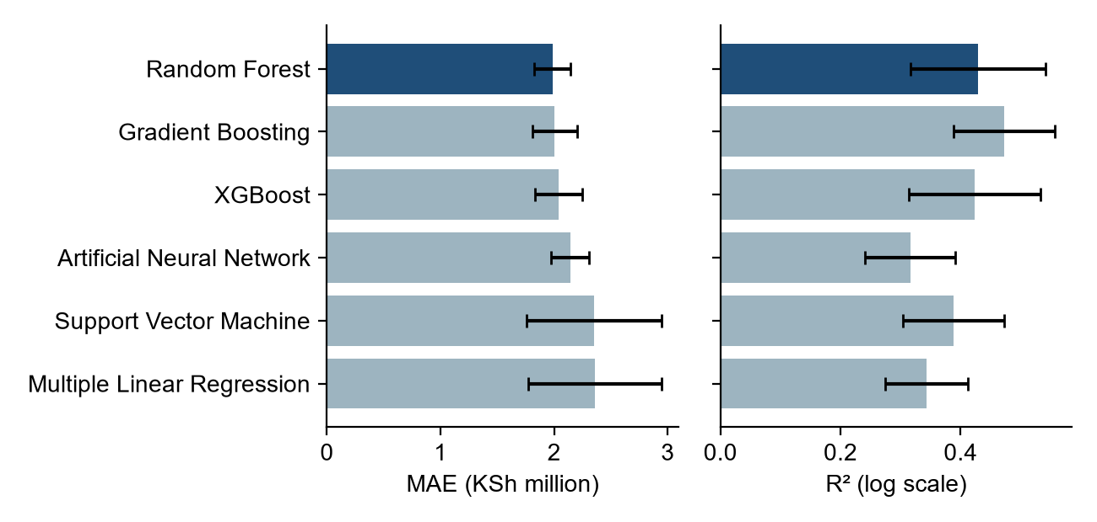
Figure 4.2: Grouped cross-validation MAE and R² (mean ± 1 standard deviation across folds). The benchmark is left out because it would distort the scale.
Four findings follow from the cross-validation:
- The tree-based ensembles perform best. Random Forest, Gradient Boosting and XGBoost have the lowest errors, with MAEs of about KSh 2.0 million. Their fold-to-fold standard deviations of MAE (KSh 0.16–0.21 million) are about a third of those of the linear and kernel models (about KSh 0.59 million), which makes them more consistent, one of the aims of a standardised model.
- Random Forest and Gradient Boosting are statistically indistinguishable. Random Forest has the lowest MAE, while Gradient Boosting has a slightly higher R² and a lower median percentage error. Their differences are smaller than one standard deviation across folds.
- All the machine learning models beat the comparable-sales benchmark by a wide margin. Multiplying a section-wide price per acre by parcel area greatly overvalues large holdings, because the price per acre falls steeply as parcels get bigger (Section 4.7). The machine learning models capture this nonlinear relationship.
- The bounded neural network is stable but not better than the ensembles. With the safeguards described in Section 4.5, the network reaches a mean error of KSh 2.14 million, ranking fourth, and its errors vary little between folds (sd KSh 0.17 million). However, it explains less of the variation in log value (R² 0.32) than any other machine learning model, and its median error (62%) is the highest. With about 1,400 records and nine mostly categorical or binary features, there is too little complex structure for a neural network to outperform tree ensembles, which is consistent with the general finding that ensembles dominate on small tabular datasets.

4.6.3 Selected model
Random Forest is retained as the selected model because it had the lowest validation MAE (the criterion in Section 3.10.4), the lowest cross-validated MAE, and low variability across folds. Gradient Boosting is a close alternative of equal standing. Figure 4.3 compares Random Forest's test-set predictions with the actual assessed values. Predictions follow the right overall trend but are compressed towards the middle: the model overvalues the cheapest parcels and undervalues the most expensive ones. This is the expected pattern when the available features explain only part of the variation in price. In practical terms, the median absolute error is about 56% of the assessed value, so the model gives an indicative price range rather than a precise valuation.
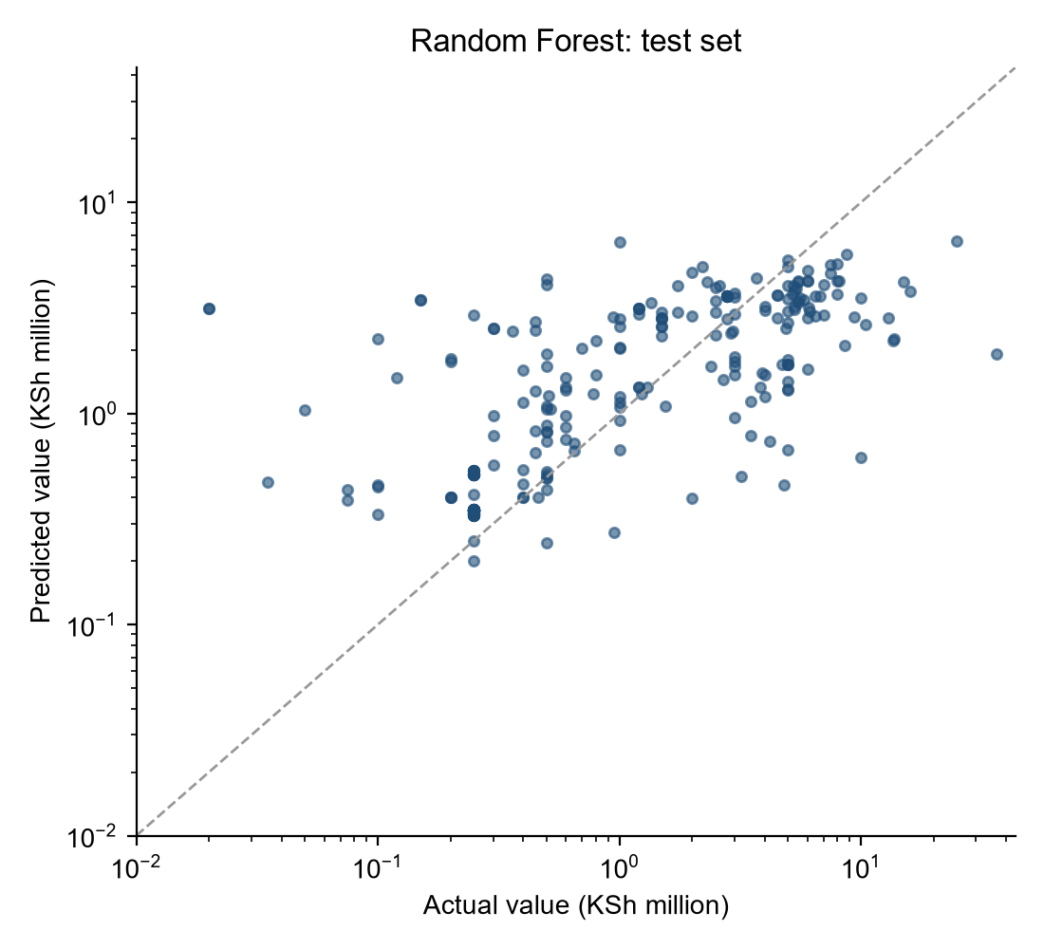
Figure 4.3: Actual and predicted values for the Random Forest model on the held-out test set (log scales; the dashed line marks a perfect prediction).

4.7 Model Explainability
Two complementary explainable-AI methods were applied, as proposed in Section 3.10.6. Permutation importance measures how much the model's error increases when the values of one feature are randomly shuffled. SHAP (SHapley Additive exPlanations) values break each individual prediction down into contributions from each feature.
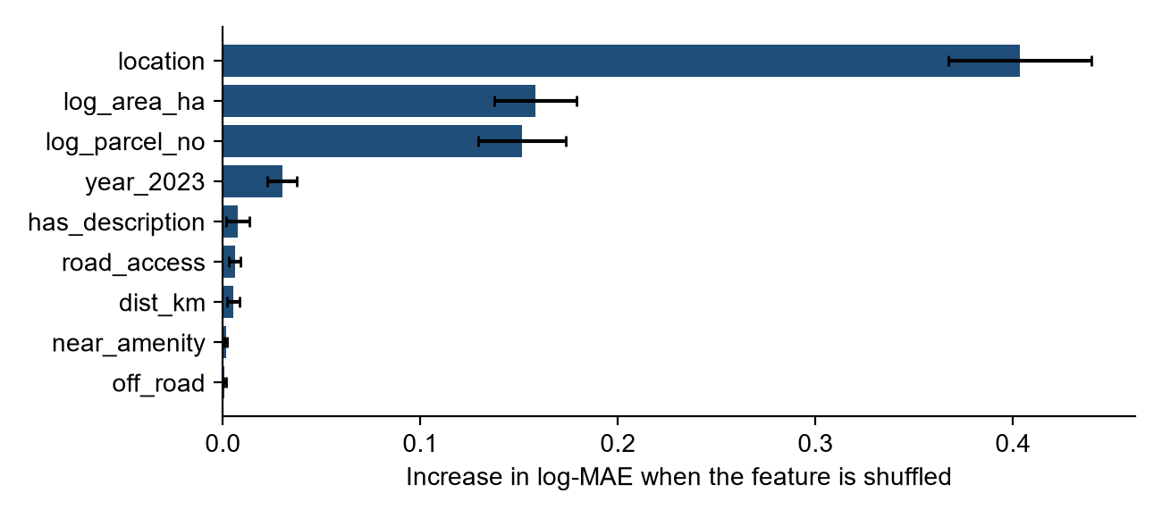
Figure 4.4: Permutation importance for the Random Forest model on the test set (mean ± sd over 30 repeats).
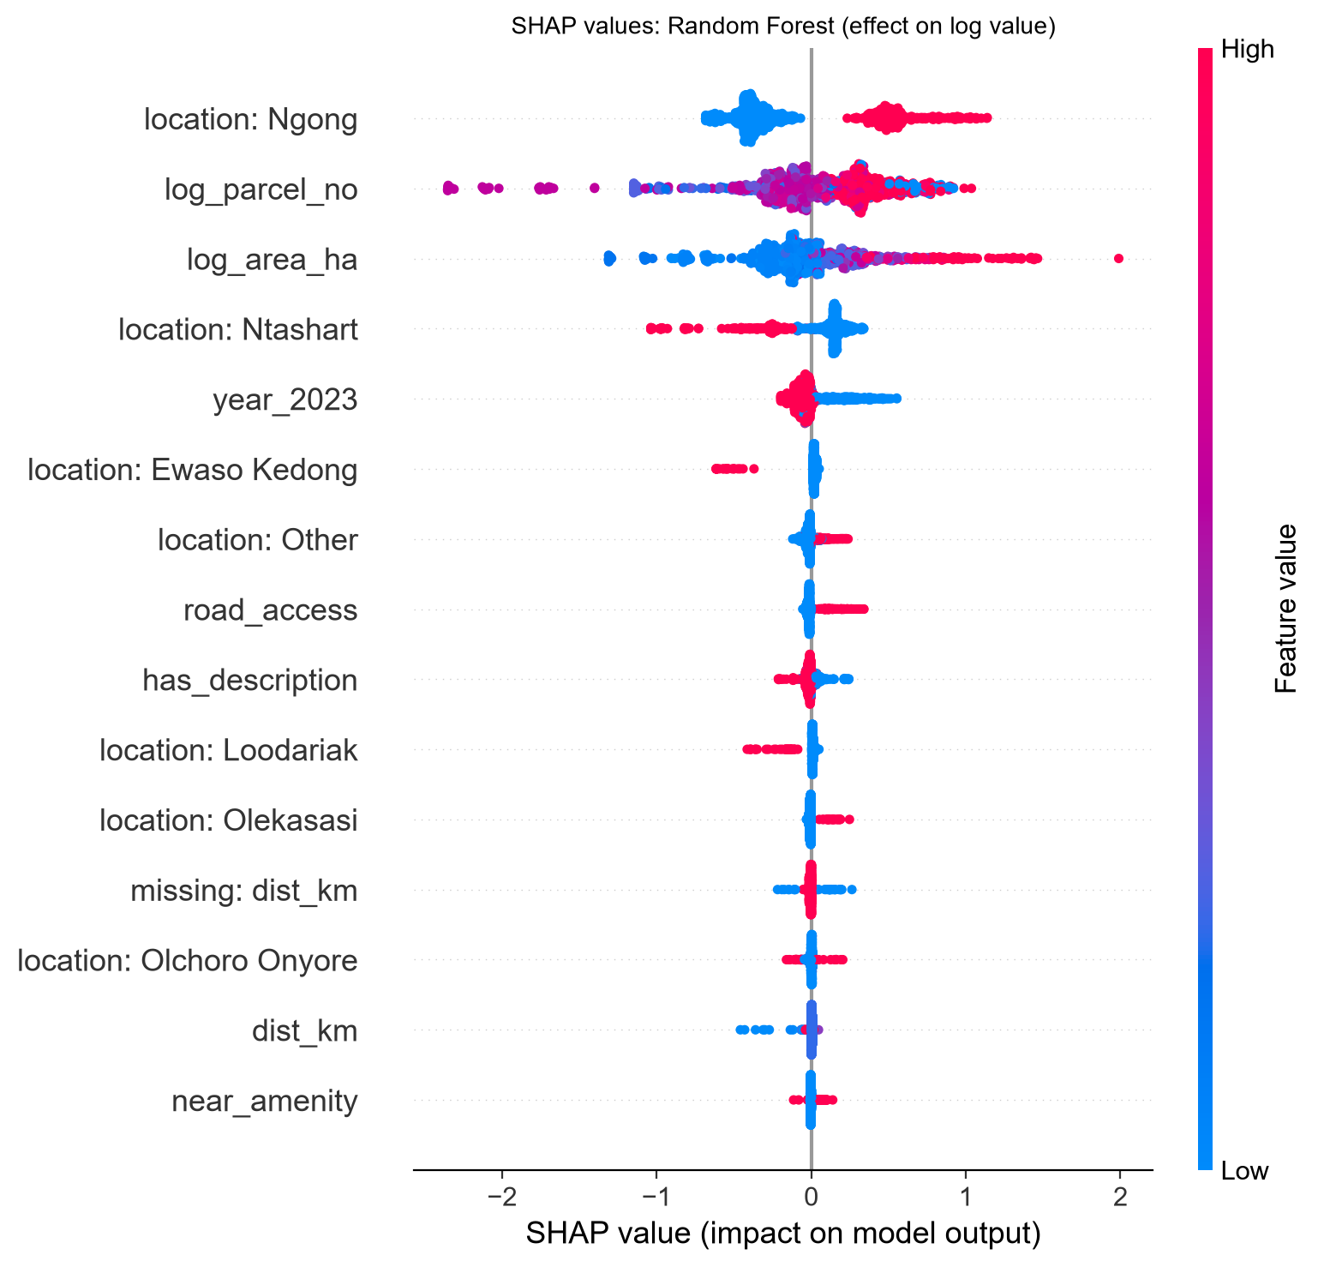
Figure 4.5: SHAP summary for the Random Forest model. Each dot is a parcel; its position shows the feature's effect on predicted log value, and its colour shows the feature value (red high, blue low).
The explainability results lead to five findings:
- Location is the dominant determinant. Shuffling location increases the error more than twice as much as any other feature. Being in Ngong raises predicted value most strongly, by about 0.4 to 1.1 on the log scale, or roughly 50% to 200%. Being in Ntashart, Ewaso Kedong or Loodariak lowers it. This supports Location Theory (Section 2.2.2) and matches the urban to peri-urban gradient described in Section 3.4.
- Parcel size raises value, but less than proportionately. Larger parcels have higher predicted values, but the effect flattens as size grows, so the price per acre falls as parcels get bigger. This explains why a constant price-per-acre benchmark fails, and supports the nonlinearity argument in Section 2.3.4.
- Parcel number carries location and age information. Parcel number is the third most important feature. It probably reflects when the parcel was subdivided and where it lies within a section, since newer subdivisions have higher numbers and are often small peri-urban plots. Some of its influence may also come from batch effects that remain even after grouping, so it should be replaced by proper spatial coordinates when these become available.
- The year effect is small. Being valued in 2023 rather than 2022 has a small and mostly negative effect, which is consistent with the stable medians across the two years. It should not be read as a market trend, because 2022 is under-represented in the modelling data.
- Text-derived accessibility indicators matter little. Road access has a small positive effect where it is recorded. The distance and amenity indicators are recorded for fewer than 5% of parcels and contribute almost nothing. This reflects how little is recorded about these factors, not evidence that accessibility is unimportant.

4.8 Discussion

4.8.1 Performance of machine learning techniques (Objective 3)
The results support the claim that machine learning can improve the accuracy and consistency of land pricing in Kajiado County. Every tuned machine learning model cut the cross-validated error of the comparable-sales benchmark by 83–86%, and the ensemble methods were also the most stable across folds. The better performance of the tree-based ensembles over linear regression is consistent with Rodriguez-Serrano (2025), who argues that conventional hedonic models struggle to capture nonlinear relationships and interactions. That Random Forest performs as well as or better than XGBoost agrees with Kochulem et al. (2023), who found Random Forest the best of the algorithms they tested for unimproved land in Nairobi County. Section 2.8 noted that the relative performance of Random Forest and XGBoost has not been established for Kenyan land, and this study adds evidence from a second county.

4.8.2 Design of the standardised model (Objective 4)
The resulting framework is standardised in the sense defined in Section 1.3. It is a fixed, reproducible procedure that takes the same inputs through the same cleaning, feature engineering, grouped validation, tuning and selection steps, and gives every parcel a price that varies with its characteristics. The most important design finding is methodological. In valuation registers where parcels are valued in batches, a random train-test split overstated R² by about 20 percentage points. Grouping by parcel block should therefore be part of the standard protocol. This supports the emphasis in Section 2.8.7 on validation and generalisation, and the warning in Section 2.4.5 that data leakage can make automated valuation models appear better than they are.

4.8.3 Validity of the model (Objective 5)
Judged on unseen parcel blocks, the selected model explains about 41–46% of the variation in log land value, with a median absolute error of about 56%. This is good enough to rank parcels and flag valuations that look out of line with comparable parcels. It is not yet accurate enough to replace a registered valuer's individual assessment, which is consistent with the decision-support role the model is intended for (Section 1.6). The main constraint is the information available rather than the choice of algorithm: the six machine learning models perform within a narrow band of each other (mean errors of KSh 1.98–2.36 million), which is what one would expect when every model can only use the same limited set of features. Jafary et al. (2024) stress that the performance of automated land valuation depends on a comprehensive set of influencing factors. Here, only location, size and time were consistently available, while the infrastructure, land-use, environmental and spatial variables in the conceptual framework were absent.

4.9 Limitations
- Missing spatial and infrastructure variables. The register has no coordinates, road network data, utility data, zoning or environmental attributes. Distance features could only be taken from free text and are available for fewer than 5% of parcels.
- Assessed values, not transaction prices. The target variable is the value assessed by the valuer, which may differ from the price actually paid in a sale.
- Short and unbalanced time period. Only 2022 and 2023 are represented, and 81% of the modelling records come from 2023, so market trends over time cannot be estimated.
- Data quality. The data were transcribed from handwritten records. Some section names could not be matched (grouped as "Other"), and some values may contain transcription errors that cleaning could not detect.
- Indicator for vacant land. Developed parcels were identified from keywords in the Situation text. Some parcels with buildings may remain in the data, which would increase their values.
- Neural network and sample size. The neural network was only stable once its inputs were bounded and its predictions capped to the training range. With about 1,400 records it did not outperform the tree ensembles. A larger dataset with richer continuous features, such as GIS distances, would be needed to test whether a deeper network adds value.

4.10 Summary and Recommendations
Six machine learning algorithms and a comparable-sales benchmark were developed, tuned and validated on 1,410 vacant-land valuations from Kajiado North. Validation used a grouped design that prevents batch-valued neighbouring parcels from inflating the results. Random Forest was selected, with an average error of about KSh 2.0 million and R² of about 0.43 on the log scale under grouped cross-validation. Gradient Boosting and XGBoost performed similarly, and all three clearly outperformed the comparable-sales benchmark. Location, parcel size and parcel number (as a proxy for subdivision) were the main drivers of predicted value.
Recommendations
- Geocode each parcel by linking parcel numbers to the cadastral map, then derive the GIS variables proposed in Stage 4 (distance to the Magadi Road and other highways, to Ngong, Kiserian and Ongata Rongai towns, and to water and power lines) and re-run the same pipeline.
- Add sale-price data from the Ardhisasa platform or land control board records, so the model can be validated against actual market prices as well as assessed values.
- Use grouped (spatial or batch-based) cross-validation as a standard requirement whenever automated land valuation models are built from valuation registers.
- Use the Random Forest or Gradient Boosting model as a screening tool that flags valuations falling far outside the predicted range for review, rather than as a substitute for professional valuation.

